Humat, Inc. 201 E. Jarrettsville Road
Forest Hill, MD 21050
(800) 638-2079
(410) 879-1470
(410) 836-5138 fax
www.humat.com

OPERATING TIPS

FOR THE HUMAT 4-WAY HYDRANT VALVE

Keep in mind that the Humat 4-way Hydrant Valve is the simplest to use and maintain appliance available today. The text of this sheet of operating hints and maintenance procedures are for those persons involved with instructing others on its use and care and should not be misconstrued as making our valve complicated. We offer these words to help those of you who must write your departments technical directives.

The valve is attached to the hydrant by holding the carrying handle with the right or left hand, centering the valve on the male hydrant thread and turning the valve’s steamer swivel in a clockwise direction with the other hand. Before tightening the valve on the hydrant, determine what position would be best for the most effective fire fighting. For Example: If you are laying in to a fire which is to your left as you face the hydrant, you should rotate the valve so that the small chamber is up instead of down. This will avoid a reverse twist in the pre-connected line. The valve steamer connection should be tightened and the hydrant charged as directed.

On the fire ground with the valve connected to the hydrant, you have more leverage and the valve can be operated easily when the butterfly is properly adjusted. To open the butterfly valve, pull the operating handle towards the closed position with one hand while pressing on the latching pin with the other hand. The latching pin will easily disengage from its locked closed position. Then, while guarding the operating handle with one hand, bump the handle with the heel of the other hand toward the open position. Because of the design of the resilient seal used with the butterfly, friction will then be hold the valve closed. Once the seal is broken, the handle can be moved easily throughout the 75 degrees of movement from fully closed to fully open position. To close the valve, move the operating handle toward the closed position slowly to prevent water hammer (as with any quarter turn valve). As you approach the fully closed position, more pressure is required to close the valve (you are compressing the resilient seal against the interior wall of the valve). Finally, when the latching pin is almost in the closed-locked position, give a brisk tug toward the closed position and the latching pin will engage in the closed-locked position on the latching plate.

When the butterfly is properly adjusted, it may seem to be difficult to open and close the valve when it is not mounted on the hydrant. Even though properly adjusted, you may wish to reduce the latching pressure temporarily for purposes of demonstrating the valve functions in a classroom situation. This is easily accomplished by loosening the latching plate clamp and repositioning the plate to suit your needs. Upon completing the training session be sure to readjust the latching pressure as per instructions.

BUTTERFLY DISC REPLACEMENT

1. Remove flanged fitting from the outlet of large chamber. (Usually male fitting).

2. Move operating handle toward closed position so that the two 7/16” bolts securing the
butterfly valve in shaft are accessible. Remove the two 7/16” bolts.

3. Place operating handle in the open position and slide butterfly valve disc out of the
shaft and valve body. (It may be necessary to give the disc a sharp tap with a hammer
handle or rubber mallet to get it started).

4. Remove shaft from valve body and clear any silicone rubber sealer from slot in the
shaft. Slot should be completely clean and free of dust and grease. Use solvent if
necessary, but be sure to dry surface completely because solvents affect curing of
sealer. Now check butterfly fits into shaft. Look for burrs and notice area in slot to
be filled with sealer in the next step.

5. In this step use Dap 100% Silicone Rubber Caulk. (If Dap is not available you can
substitute Dow Corning or GE Silicone Rubber Sealer.) Apply liberal amount of
sealer at each end of slot, use common screwdriver blade to press sealer into corners
of slot. Smooth sealer carefully and taper it about out up sides of shaft toward bolt
holes. Also smooth some sealer on butterfly edges where it seats inside shaft to aid
adhesion when assembled.

6. Replace shaft in valve body, making certain there is no sealer on outside of shaft.

7. Place the butterfly valve disc in valve body and shaft slot. Do not allow butterfly
disc to pass thru slot. Some may side thru – others will need to be pushed.

8. While holding butterfly disc in position, turn operating handle toward closed position
until you can see the holes in shaft and disc enough to align them. Apply a small
amount of sealer around the underside of the ¼” hex head bolts. Later models will
have two o-rings on bolts. Replace the two ¼” bolts and tighten only finger tight.

9. Wipe off excess sealer on the butterfly disc and inside the valve body.

10. Loosen the clamp bolt on the latching plate only enough to allow the latching plate
to turn on its boss. Now place a strip of cardboard about twice the matchbook cover
thickness between the disc and the body wall on side that is farthest away from the
engine connection so as to bias the disc to one side of the bore.

11. Move the operating handle toward its closed position until the latching pin engages
itself in the locked-closed position. While holding pressure toward the closed
position with one hand, with the other hand use a hammer handle or wooden dowel
to tap around the circumference of the butterfly disc from the hydrant connection
end until it has seated itself. While still holding pressure on the operating handle
and latching plate toward the closed position with the one hand, retighten the ¼”
bolts holding the butterfly disc. Do not over tighten – remember these are only
¼” bolts.

12. Move the operating handle to the locked-open position and use a common
Screwdriver blade to press a small amount of sealer in the void at each end
of the slot between disc and wall. Use a vibrating and packing motion to fully
pack void. Shaft can be moved a small distance to one side, then the other to aid
in packing. Do this to aid in packing. Do the to both sides from the engine
connection then from the hydrant connection end. After applying sealer at both
sides from both ends, close the valve and wipe off any excess sealer. Then with a
dry cloth open the valve and do the same. Depending on the condition, curing time
will vary. Normally the sealer will cure sufficiently in six hours to place the valve
back in service. It will fully cure in twenty-four hours.

13. If excess leakage persists at shaft, repacking may be necessary. To place valve in
service, adjust the latching plate to lock butterfly closed as follows:

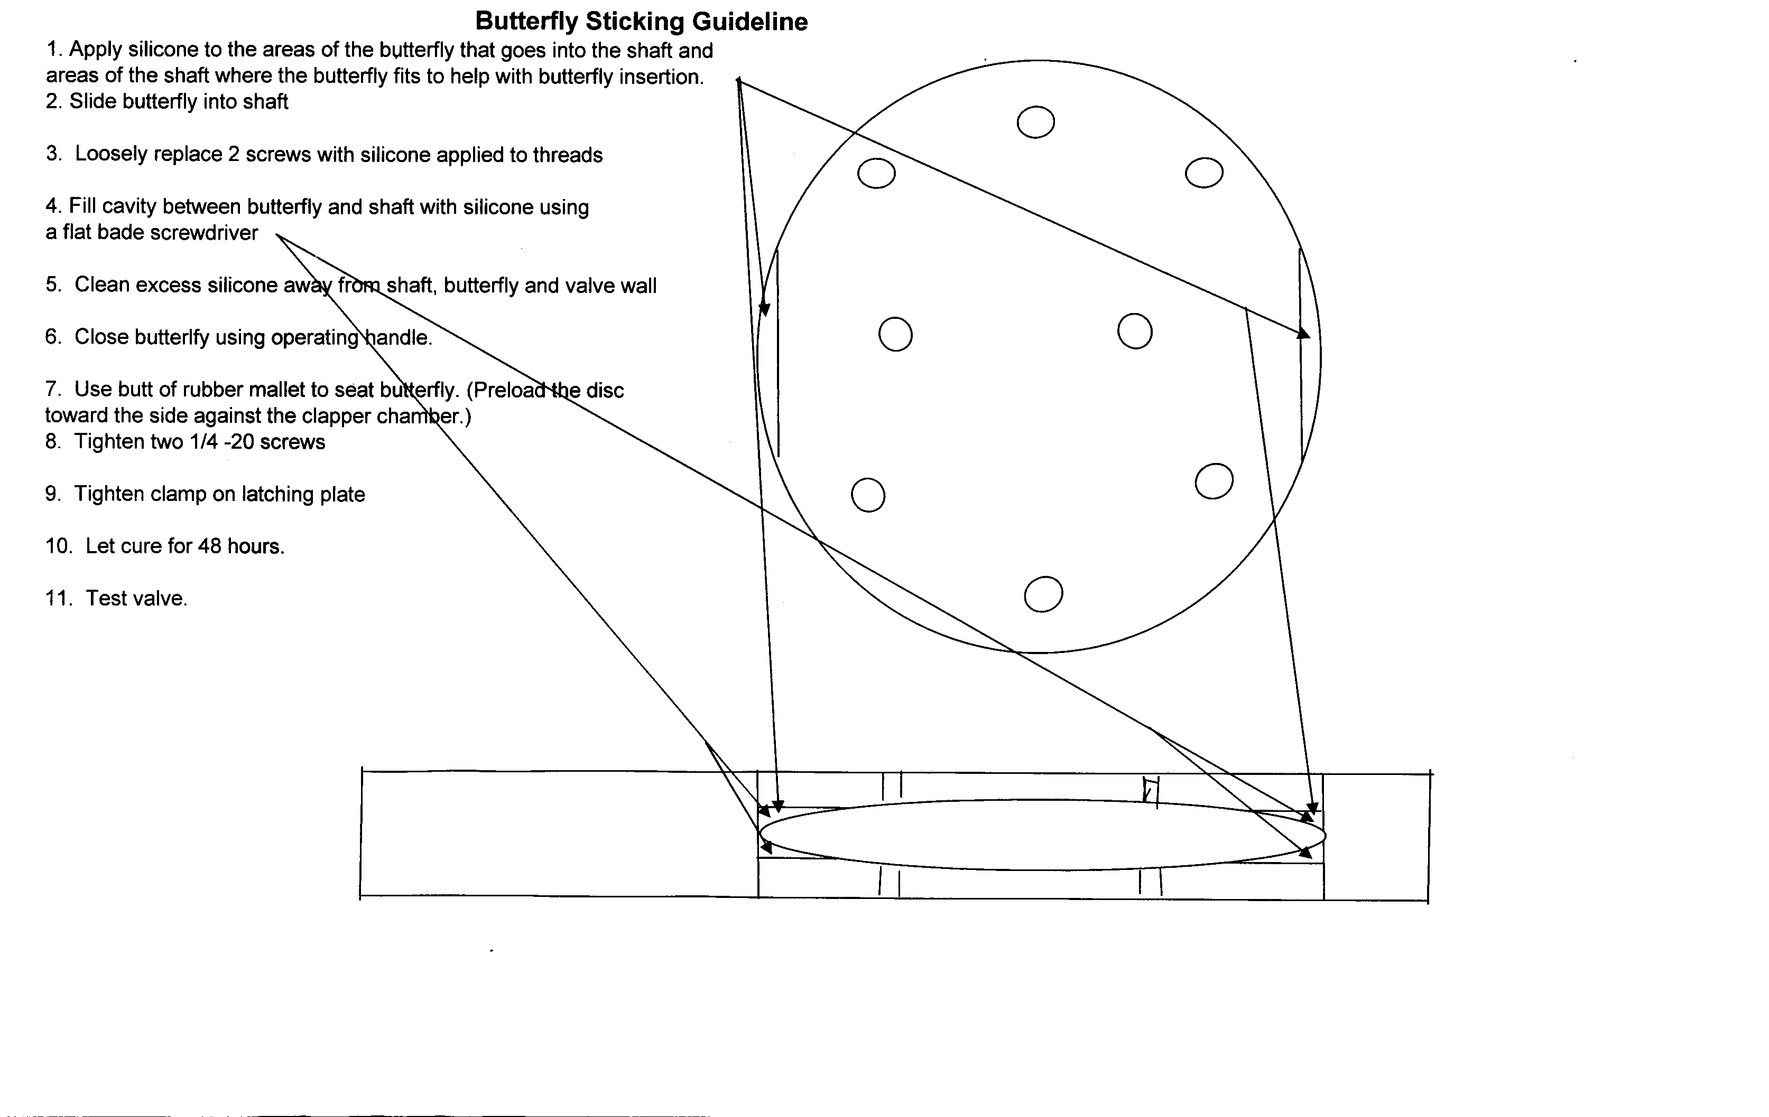

ADJUSTMENT OF BUTTERFLY DISC

The butterfly type valve in the large chamber is designed to restrict water flow sufficiently to connect a pumper’s soft or hard suction. A small leak at each end of the butterfly shaft is acceptable to most. With the butterfly replacement completed as outlined above, the following adjustments should be made:

1. While the valve is attached to a hydrant, or engine suction to aid in holding, lube the
scrub area of the o-ring on wall, being careful not to get lube on uncured silicone.
Manually close the butterfly valve in the large chamber and place in locked-closed
position.

2. Loosen the two ¼” cap screws that hold the butterfly disc in place in the shaft, just
enough to allow the disc to move with firm pressure. Place two opened matchbook
covers (with matches and strikers removed) between the disc and the wall at the edge
that is closest to the hydrant connection when closed and then close the valve.
Remove valve from hydrant and using a hammer handle, tap the disc near the
cardboard from the hydrant connection end maintaining pressure on the valve handle.
Then retighten the two ¼” cap screws to lock disc in place. Next, remove cardboard
and adjust the closing pressure by moving latching plate.

To adjust closing pressure, mount valve on a hydrant or engine suction again to aid
holding and loosen latching plate clamp. Push latching plate down on boss to provide
clearance between it and the operating handle and tighten clamp. If adjusted properly,
firm tension should be needed to bring latching pin to seat.

3. These adjustments should virtually eliminate the leak. When adjusted properly, the
Humat Valve will have only a negligible amount of leakage past the butterfly disc. It
will vary with pressure and use. It may be necessary to experiment with the closing
adjustments to find the best operation for your condition. Note that generally, the rule
“the tighter the seal – the less leakage” applies.

MAINTENANCE TIPS

FOR THE HUMAT 4-WAY VALVE

The Humat 4-way valve is essentially maintenance free, since there are no packing glands or sophisticated seals used in it. Adjustment of the butterfly can be done externally. See “Butterfly Replacement and Adjustment” for adjustment procedures.

Lubrication, such as a mixture of oil and graphite or equivalent, is recommended for the threads. The pellet bearings and races on the female swivel do not require lubrication; however, the swivels will turn more easily when lubricated. If a lubricant is used, dry graphite is recommended. Remove the slotted set-screw on the swivel and apply a small amount of graphite through the set screw hole. An oil based lubricant will tend to pick-up dirt and debris which prevents smooth turning of the swivel.

When replacing a broken female, remove set screw and then remove pellets (don’t lose pellets). Check that receiver groove has had no damage. With the receiver and new female together replace the pellets, once this is done replace with new set screw. CAUTION: do not over tighten the set screw. Check assembly by rotation of flange to assure free spinning. Then using a hammer and screwdriver stake the new set screw into place.

All flanged fittings can be removed by simply removing the bolts holding the flange on the valve body. When replacing a flange, be sure the o-ring seal is properly seated in the groove provided. A good procedure is to place the o-ring in the groove, place the flange in position and hold it there until you have one bolt on either side of the flange finger-tight. This should hold the o-ring in position until all bolts are replaced and tightened securely.

The clapper disc operates automatically by differential water pressure. It has two seats, one between the large and small chambers and one at the small chamber inlet. Should leakage be observed at the small chamber inlet while the valve is under hydrant pressure, the clapper is not seating properly. After shutting down the hydrant, check the surface of the clapper disc where it comes in contact with the small-chamber seat. Run the tip of your index finger around the small chamber-seat to determine if any debris has accumulated. Any foreign matter present on the clapper or its seat must be removed to maintain a good seat.

After checking for debris, the clapper disc should be checked to be sure there is some “play” where the clapper is attached to its stainless steel shaft. The “play” enables the clapper to seat itself.

